PRACTICE CASE 07-1:

**BUSINESS ACUMEN**

Haries Ramdhani

Assume you are a product manager/data scientist (or anyone who has capability to make a change) in a Startup. The startup name is BukaToko and they are one of largest marketplace. Their main vision is to help small businesses to get wider market and buyers can buy product safely. This company also creates trusted payment ecosystem for both seller and buyer. Event though they have a complex security to protect transaction of sellers and buyers, several frauds have inflicted loss to all parties, especially BukaToko themselves. Cashback fraud, Fake “Cheap” Product, Transaction outside platform, Fake shipping receipt, and so forth are the problems that harmful and need to be solved soon. You, as the one who dedicated to stop these problems, need to make your own team to cooperate and solve these

1. **Which problem you prioritize the most? And Why? (Choose one and focus on that topic)**

Among all of the problems served in the story, I’ll give the highest priority to the cashback fraud case because it’s a serious issue that many startup e-commerces in Indonesia are facing right now. Cashback fraud is serious case in a way that it can cause company’s loss to be high up to millions rupiahs. Earlier this year the same case happened to one of the popular e-commerce s in Indonesia, the fraudsters caused loss as big as 70 M Indonesia rupiahs. This event was caused by three suspects took turns as sellers and buyers. If suspect number one is a buyer or seller, suspect number two and three act as buyers by buying on the e-commerce market. The suspects made a purchase transaction according to the rules in the mentioned e-commerce site. However, they made accounts as if the seller and buyer were different people. Then, they made a purchase transaction. This way the suspects could reap much money from just doing the fake transactions between each other from the cashback voucher system of the e-commerce site.

If the same story mentioned in the first paragraph happened to our company we will face the same loss. Preventing is better than curing, so if we can prevent this cashback fraud case before it happens in our company we can reduce the loss of our company’s money (especially the marketing component).

1. 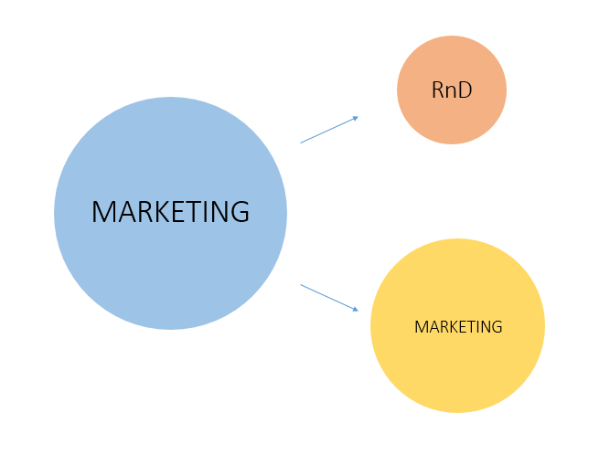**Which business components that will be your team to solve the problem? Why?**

For this problem, the business component that will focus on this matter is the marketing team namely, the RnD and the marketing team. The marketing team and RnD team together will collaborate to use the state of the art technology to combat the cashback fraud. The Marketing team will help the RnD team with the segmentation of the customers that will receive the cashback, the RnD team will help the marketing team to improve the system, so that cashback fraud won’t happen again.

1. **How you define and identify the problem?**

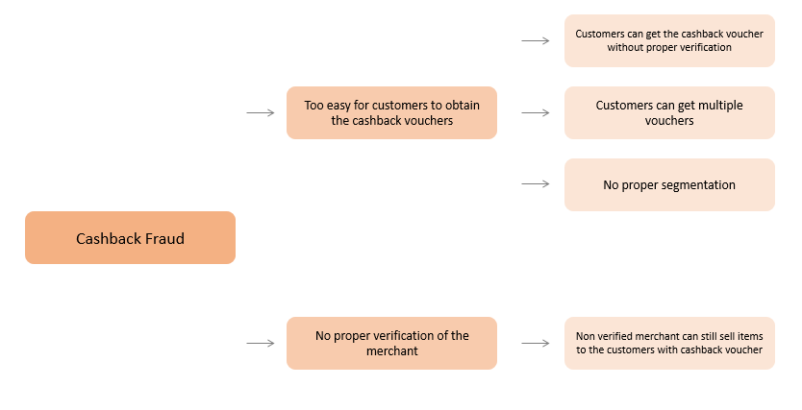

The biggest issue that the company is facing and the most probable root cause of the cashback fraud is the fact that it is too easy for customers to obtain cashback vouchers, the way that these free vouchers are given will eventually trigger the cashback fraudsters to perform such fraud. The subissues of the mentioned issue is first, customers can get the cashback vouchers without even performing ID card verification to make sure that the customer is real and not some fake customer with stolen ID. Second, customers can get multiple vouchers so they can perform many transactions. Third, there is no proper segmentation for the customers, segmentation in this case is the segmentation to send the cashback vouchers. Another part of the issue is coming from the merchant side, the merchant can still sell its items without proper verification, so they can even sell fake items and get away with everything.

1. **What is your synthesized solution?**

For this problem I proposed several solutions

1. The RnD team can improve the company’s anti-fraud tracking system, this way it’d be easier to track the fake transactions (cashback fraud) from the real transaction ones
2. Only give the cashback vouchers to the clients who are properly verified, peroperyly verified in this case means that the client has to take a picture of their own together with the ID card.
3. Cashback vouchers have to be limited only to the official store or stores that are properly verified. This way we can get away with the cashback fraud problem.